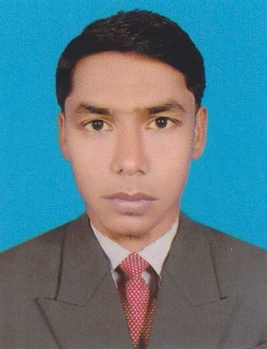**RESUME OF**

**MD. ABDUL MOTIN**

**Contact Address:**

Mobile: 01740197705

Email: motiniu92@gmail.com

**CAREER OBJECTIVE:**

To build a career in a dynamic and challenging work environment where I will be able to develop and enhance my skills and knowledge through strong teamwork and sincere co-operation.

**PERSONAL DETAILS:**

Father’s Name **:** Md. Hayat Ali

Mother’s Name **:** Sajenur

Date of Birth **:** 10/04/1992

Sex **:** Male

Height **:** 5 feet 4.5 inches

Blood Group **:** O+ (Positive)

Mailing Address **:Vill:** Tarapur, **Post**: Sahapara, **PS**: Shibganj

Permanent Address **:Vill:** Tarapur, **Post:** Sahapara, **PS:** Shibganj

Home District **:** Chapai nawabganj

Marital Status **:** Unmarried

Nationality **:** Bangladeshi

Religion **:** Islam

**ACADEMIC QUALIFICATION:**

|  |  |  |  |  |
| --- | --- | --- | --- | --- |
| **Exam Title** | **Concentration/**  **Major** | **Institute** | **Year of** **Passing** | **Results** |
| MTIS | Al Hadith & Islamic Studies | Islamic University | 2014 | 3.40 |
| BTIS | Al Hadith & Islamic Studies | Islamic University | 2013 | 3.30 |
| Alim | Humanities | Shibganj Fajil Madrasha | 2009 | 3.42 |
| Dakhil | Humanities | Tarapur Dakhil Madrasha | 2007 | 3.42 |

**MAJOR STRENGTH AREAS:**

* Committed to work for the betterment of the organization as well as its people;
* Interpersonal and communication skills;
* Dynamic, energetic, organized and self-motivated;
* Willing to learn new skills and expertise;
* Ability to strategically plan, develop and implement programs and operations toward achievement of team’s mission, goals and objectives; and
* Ability to work under stress and long hours.

**LANGUAGE PROFICIENCY:**

|  |  |  |  |  |
| --- | --- | --- | --- | --- |
| **Language** | **Reading** | **Writing** | **Speaking** | **Listening** |
| English | High | High | Medium | Medium |
| Bengali | High | High | High | High |
| Arabic | High | High | Medium | High |

**COMPUTER SKILLS:**

|  |  |
| --- | --- |
| Operating System | DOS, Windows |
| Office Application | Word Processing with MS Word, Spread Sheet Analysis with MS Excel, Database Management with MS Access. |
| Internet Operation | Email, Web browsing |

**REFERENCES:**

|  |  |
| --- | --- |
| **Referee 1** | **Referee 2** |
| Dr. Md. Saiful Islam Siddiqi  Professor  Department of Al Quran & Islamic Studies  Islamic University- Kushtia.  Mobile: 01766165604  Email: drsaif.siddiqi@gmail.com | Dr. Md. Lokman Hossain  Professor  Department of Al Quran & Islamic Studies  Islamic University- Kushtia.  Mobile: 01718679586  Email: drloqmanhusain@gmail.com |

**DECLARATION:**

I declare that the information provided in the curriculum vitae are correct, true and complete to the best of my knowledge and belief. If any information is found false, incorrect or incomplete, any action can be taken against me by the authority.

Date: Signature